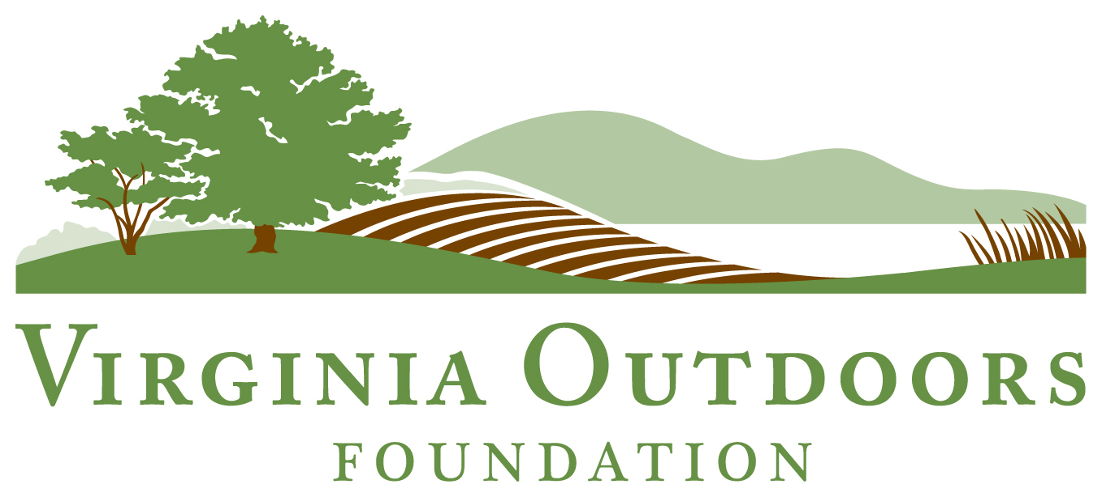

Preservation Trust Fund- Easement Assistance Application

General Information (Each owner, entity, and entity member/s must submit tax forms and provide contact information on Page 4)

Main contact for Property: ________________________________________________________________

County _______________________________________ Number of Acres _________________
Address ______________________________________ Phone _____________________________
______________________________________ Email _____________________________

Name of Trust, LLC or other entity, if applicable __________________________________________________
Please submit entity tax forms and provide member contact information on Page 4

1) Is the property a family-owned or family operated farm or forest? Yes No
2) List crops, livestock, and/or farm or forest products produced, and list acreage devoted to each.
__________________________________________________________________________________________
__________________________________________________________________________________________
3) Describe family’s involvement in farm or forestland operation (family employment full/part-time, etc.). ____________________________________________________________________________________________________________________________________________________________________________________

4) Length of family ownership_______________

Return the following documents to the Virginia Outdoors Foundation at:
PO Box 85073, PMB 38979, Richmond, VA 23285-5073.

Copies of IRS tax returns (Pages 1 & 2 for the most recent two years available for each owner/entity and for each entity member if applicable).
Completed Application
Non-Filer Affidavit (Page 5), if applicable

Owner’s signature ______________________________________ Date: ________________________

Estimate Your Easement Expenses

Landowner: ___________________________________ County: ______________________ Acres: _______

 | ANNUAL INCOME | Average Award | Available for VOF fees | Available for landowner legal and appraisal costs
1 | Up to $70,000 | $14,000 | Up to $5,000; covers 100% | $6,500-$10,000; 100% cost share
2 | $71,000 – $85,000 | $10,500 | Up to $5,000; covers 100% | $5,500-$7,500; 75% cost share
3 | $86,000 – 105,000 | $2,250-$3,000 | 100% of Processing fee;50% of BDR fee up to $3,500 | $0

Estimate your total costs in the space provided below. Discuss the price of the BDR preparation fee with your Senior Conservation Specialist. You may ask for additional funds if you provide a written estimate from your
attorney and/or appraiser.

Example: Your Request:
Legal: $3,000
Appraisal: $4,500
VOF Proc. fee: $1,500
VOF BDR Fee: $3,500
Total Request: $12,500
Legal: ___________________
Appraisal: ___________________
VOF Proc. fee: ___________________
VOF BDR Fee: ___________________
Total Request: ___________________

Financial Need Information
Please use the space below or attach a separate note to describe the reason for additional funds, i.e., large parcel, complicated legal description, etc. You can also use this space to describe financial need factors that may not be revealed by the federal tax forms.

________________________________________________________________________________________________________________________________________________________________________________________________________________________________________________________________________________________________________________________________________________________________________________________________________________________________________________________________________________________________________________________________________________________________________________
________________________________________________________________________________________________________________________________________________________________________________________________________________________________________________________________________________________________________________________________________________________________________________________________________________________________________________________________________________________________________________________________________________________________________________________________________________________________________________________________
Please provide contact information for all owners, entity (if applicable), and entity members (if applicable)

Name/s: ___________________________________________________________________________

Address ______________________________________ Phone ____________________________
______________________________________ Email _____________________________

Name/s: ___________________________________________________________________________

Address ______________________________________ Phone _____________________________
______________________________________ Email _____________________________

Name/s: ___________________________________________________________________________

Address ______________________________________ Phone _____________________________
______________________________________ Email _____________________________

Name/s: ___________________________________________________________________________

Address ______________________________________ Phone _____________________________
______________________________________ Email _____________________________

Name/s: ___________________________________________________________________________

Address ______________________________________ Phone _____________________________
______________________________________ Email _____________________________

Name/s: ___________________________________________________________________________

Address ______________________________________ Phone _____________________________
______________________________________ Email _____________________________

Affidavit for Non-Filers Landowners who do not meet the IRS requirements for filing federal returns must complete and submit this affidavit to substantiate financial need.

Affidavit
Commonwealth of Virginia
County of ________________
Before me, the undersigned Notary, _______________________________ [name of Notary before whom affidavit is sworn], on this _________________ [day of month] day of _________________ [month], 20____, personally appeared ____________________ [name of affiant], known to me to be a credible person and of lawful age, who being by me first duly sworn, on ________ [his or her] oath, deposes and states as follows that:
1. _______________________________________ [name of applicant(s)] [has or have] made application to the Virginia Outdoors Foundation for open-space land preservation trust fund assistance pursuant to Virginia Code Section 10.1-1801.1 in order to convey an open-space easement to the Virginia Outdoors Foundation;
2. Such applicant(s) [has or have] insufficient income to have been required to file a federal or state income tax return for the years ________, _________ and ___________; and
3. Such applicant(s) [has or have] a financial need for such assistance in order to make such conveyance of the open-space easement.
__________________________________
[signature of affiant]
__________________________________
[printed name of affiant]
Subscribed and sworn to before me, this _________________ [day of month] day of _________________ [month], 20_____.
___________________________________
Notary Public

My commission expires: ______________________
(SEAL) Registration No. ____________________________

